Case 8-A473-US-AK- Ketchikan-Tlingit-Totem Pole-Raven-Watchman-1920’s

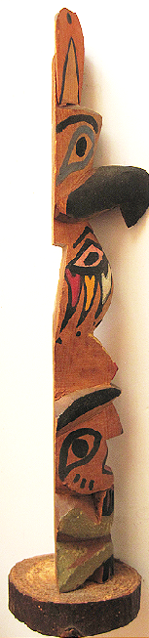 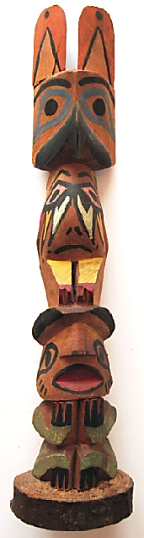 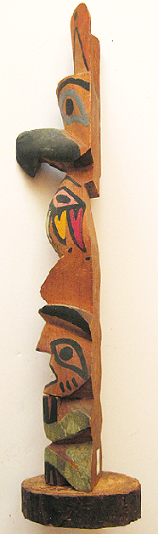 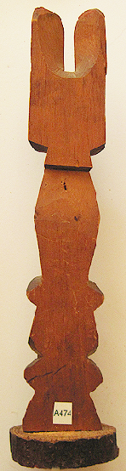

Figs. 1-4. Alaska-Ketchikan-Tlingit-Totem Pole-Raven-Watchman-1920’s

**Case no.: 8**

**Accession Number: A474**

**Formal Label:** Alaska-Ketchikan-Tlingit-Totem Pole-Raven-Watchman-1920’s

**Display Description:**

This unusual Tlingit Totem Pole has Raven above Watchman which should be reversed. Watchman is warning that there is an enemy approaching, as that is his duty. Raven has its wings furled and is not acting. A curious image beneath the Raven’s head where its body should be is what appears to be another spirit being’s head with white, yellow and red streamers cooing from its eyes, appearing like a falcon’s eye, but this is unclear. **LC Classification:** E99.T6

**Date or Time Horizon:** Early 20th century

**Geographical Area:** Ketchikan-Alaska

**Map, GPS coordinates:** 55º20'32" N 131º38'46" W

**Cultural Affiliation:** Tlingit

**Media:** Cedar Branch; yellow, pink, gray blue, black, green paint.

**Dimensions:** H 252.45 mm, 9.94 in; W 4503 mm, 1.77 in

**Weight: 89 gm, 3 1/8 oz**

**Condition: original**

**Provenance:** Ketchikan-Alaska

**Discussion:**

The myth suggests that sometimes Raven is not at all responsive to danger and one must pay heed to Watchman. Watchman is identified by his round, black cap.

**References:** Garfield, Viola Edmundson. 1980. *The Seattle totem pole*. Rev. and expanded version. Seattle: University of Washington Press. [20] p.